1st Grade Supply List

- 48 Ticondiroga #2 pencils (already sharpened)
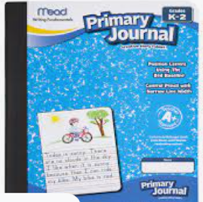
- 1 primary marble composition notebook labeled with your name
- Headphones (no ear buds please!)
- 1 box Pencil-top erasers
- 2 boxes of Twistable crayons (no silly scents)
- 1 box of washable markers
- 12 small glue sticks
- 1 pack of 4 black dry-erase markers (Expo brand if possible)
- 1 pair of scissors
- 2 plastic folders
- Box Facial Tissue (recommended to help out our classroom)
- Ziploc gallon bags (for all sorts of fun things)
- Ziplock sandwich bags
- Plain plastic pencil box 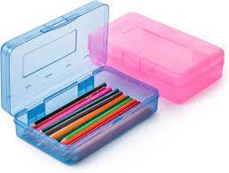

Note: I will supply the kids with their “take home folders”. They will be durable red folders. ☺

If your family needs support in purchasing any of the supplies listed, please contact Bailey Pangman at bpangman@niskyschools.org or (838)200-3954. All requests always remain confidential.

