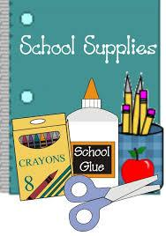
SECOND GRADE SUPPLY LIST

REQUIRED SUPPLIES:
- 3 plastic pocket folders (red, green, yellow)
- 2 jumbo glue sticks
- 2 - 24 count Crayola crayons
- 1 -8 pack of markers
- 2 dozen sharpened #2 pencils
- Headphones that are compatible with Chromebook
- 6 skinny dry erase markers- BLACK ONLY PLEASE!
- 1 dry erase board eraser
- Scissors
- Erasers or Eraser Caps:
- 2 box of tissues
- Diwipes

Please label supplies with your child’s name and send them in on
the 1st day of school. THANK YOU for supporting our classroom!

If your family needs
support in purchasing
any of the supplies
listed, please contact Bailey Pangman at bpangman@niskyschools.org or (838)200-3954. All
requests always remain confidential.

