Communications Classroom
Hillside Elementary
Supply List 2024-2025
It’s that time to prepare for a wonderful year in the Communications Classroom at Hillside! The following supplies are recommended for your student to use within the classroom.
- backpack
- pencil box
- 1 box of pencils
- 8 large glue sticks
- 1 package of crayons
- 1 package of washable markers, classic colors
- 2 packages of dry-erase markers
- 1 dry marker eraser (or sock)
- 1 pair of Fiskars blunt-tip scissors
- 4 boxes of tissues
- 3 containers of Play-Doh
- 2-3 containers of lysol disinfecting wipes
- 1 plastic, two pocket folder
- 2 boxes of ziploc bags (Kindergarten: sandwich size/gallon size,
1st: snack/quart size)
- change of clothes in a ziploc bag (please label with name).
- If your child is potty training or has a tendency to need to change, please send up to three changes of clothes along with a wet/dry bag to send wet clothes home in. (Amazon has washable, wet/dry bags that can be reused)
- water bottle labeled with child’s name
Wish List:
The following list contains items that will be used throughout the year with the students. If you would like to make a contribution to the classroom, it would be greatly appreciated.
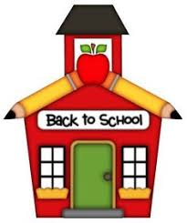
- Shaving cream
- tempera/washable paint (any colors)
- bag of beans/rice
- pony beads
- kinetic sand
- bead divider cases
- clothespins
- sensory fidgets
Thank you for all of your support, and I look forward to a successful year!
Mrs. Spizuco

