Mrs. Halayko’s Class Supply List
***You will not need separate supplies for their homeroom class***

Requested:
- 1 pack crayons (12 count or larger)
- 1 pack colored pencils (8 count or larger)
- 1 pack washable markers
- Sharpened pencils (24 or more)
- Glue Sticks: many- they eat them ; )
- Child scissors
- Paper plates or bowls (for cooking)
- 1 box Spoons or forks (for cooking)
- 2 boxes of tissues
- 1 Go home folder- 2 pocket

Optional:
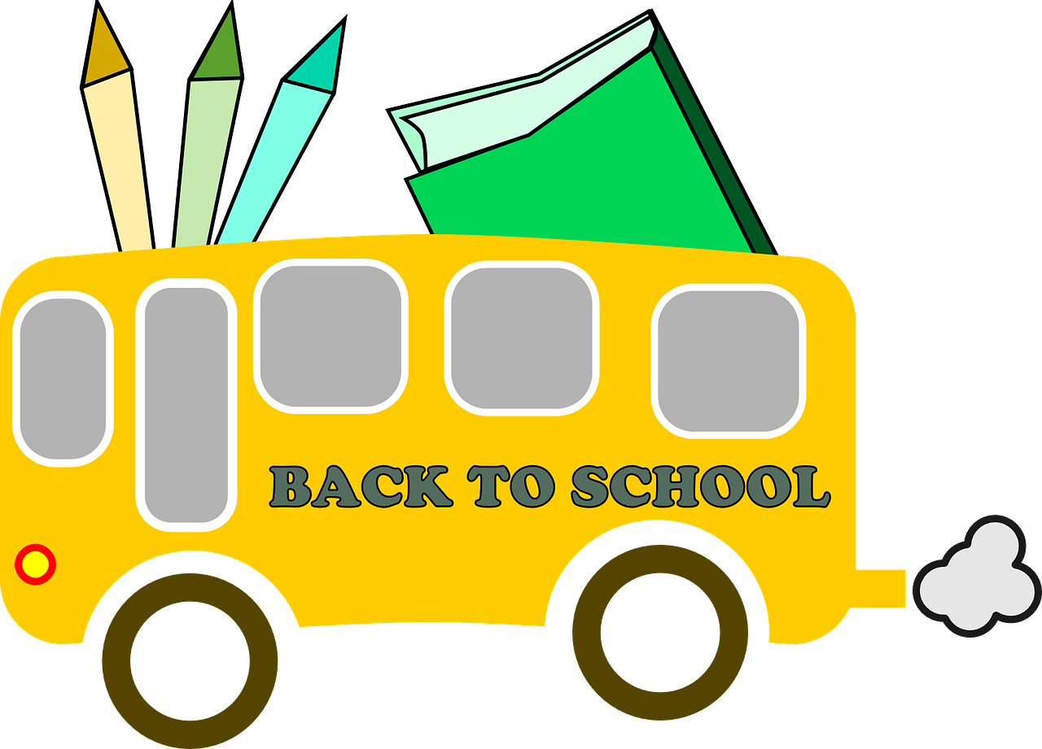
- Cleaning wipes
- Play-doh or slime

For Their general education class:
- Crayons or colored pencils
- Pencils (5-6)
- Pencil case

