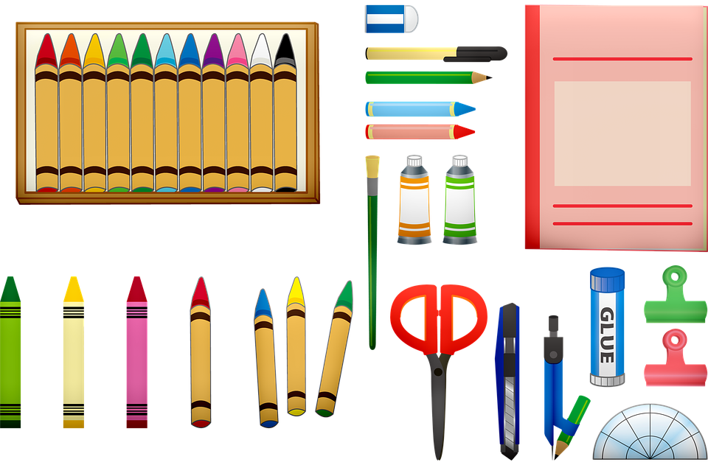
2024-2025 School Year

Dear Parents and Future Fourth Graders,
Welcome to 4th grade!! We’re very excited about getting to know you and being your teacher this year. To get us off to a great start, here’s a list of supplies that you will need for this year. Please bring them to school on the first day, Thursday, September 5th.

All 4th graders will need:
- pencils #2 (1 box of 12 sharpened)
- pencil sharpener (hand-held) 4C only
- cap erasers for pencils (small package)
- red pen 4C only
- colored pencils (twistables preferred, box of 12)
- markers (box of 8-10)
- scissors
- One highlighter (any color) 4C only

- 2 black sharpies (medium point) 4C only
- pencil case to hold supplies in desk
- dry erase markers/eraser or black felt (8 x 12) (box of 8, assorted colors)
- Tissues
- antibacterial wipes
- Earbuds or headphones (required)
- Post-It Notes, 3 x 3, 100 pack, any color, plain, no lines

Note to Parents:
Your child’s homeroom teacher will be confirmed in August. You may be asked to supply a few additional items that are unique to that teacher.

If your family needs support in purchasing any of the supplies listed, please contact Bailey Pangman at bpangman@niskyschools.org or (838)200-3954. All requests always remain confidential.

Thank you,
Ms. Castren (4C)
Mrs. DiRienzo (4D) and
Mrs. Bielawski (4B)
Thanks

